Equality, diversity and inclusion at Victim Support

Introduction

Victim Support is the independent national charity which helps people affected by crime. Our services are free and available to everyone, whether or not the crime has been reported and regardless of when it happened. We also work to promote and advance the rights of victims. To achieve this, we need to make sure that Victim Support puts non-discriminatory practices into effect in both employment and service delivery.

One of Victim’s Support’s organisational values is ensuring we are ‘Accessible’ and this means that we will be striving to work collaboratively with victims and witnesses and their communities.

The following statement of policy is for use by all employees and volunteers working within Victim Support.

Equal opportunities statement

Victim Support is committed to equal opportunities in employment and service delivery. We will take every possible step to ensure that no person working for the organisation or seeking employment with us, or anyone using our services will receive less favourable treatment or will be disadvantaged by requirements or conditions that cannot be shown to be justifiable on the grounds of their age, disability (including mental health), gender, gender reassignment, ethnicity, faith/religion, sexual orientation, marital/civil partnership, socio economic status or family status. Selection criteria and procedures are reviewed regularly to ensure that individuals are selected and treated on the basis of their relevant merits and abilities.

Diversity statement

Equality, Diversity and Inclusion are important to us. We take pride in being a diverse organisation, enriched by the participation of all individuals and communities. We recognise that prejudice and discrimination continue to result in unfair treatment for many people. We are committed to addressing this by:

ensuring the effectiveness of our Equality, Diversity and Inclusion policy

being clear and open about our values and promoting them

listening, learning and taking action to bring about change.

Our diversity statement is “Diversity matters and we value it”

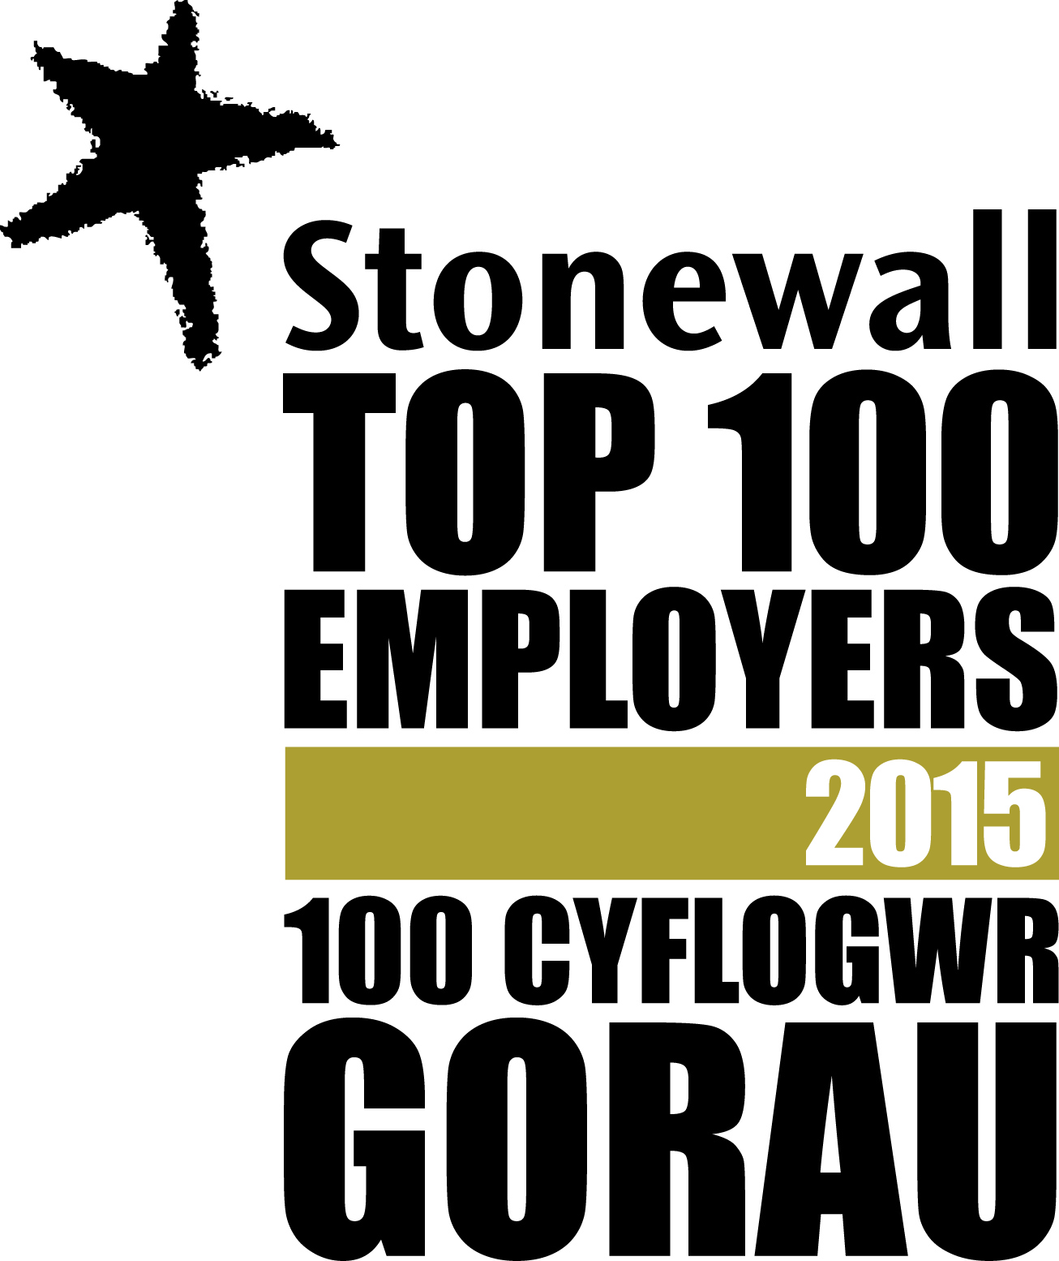 |  | 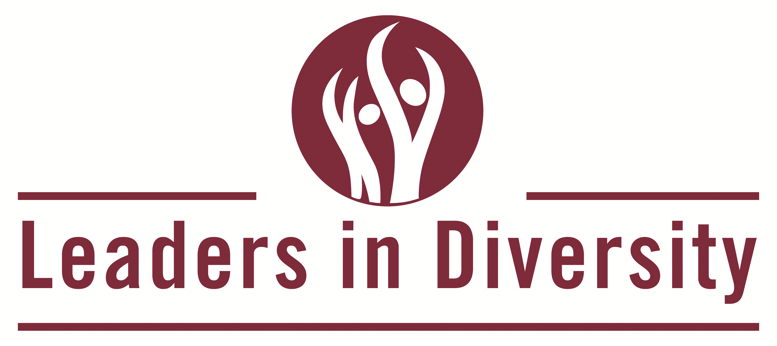 |  | 